Data Catalog With ORM stack

Contents

1. Introduction 3
2. .Workflow diagram to deploy the stack 3
3. Create stack for Data Catalog 4
4. Plan the Job 6
5. Apply the Job 7
6. Verify in the Console 8
7. Destroy the stack 10

Introduction

Oracle Cloud Infrastructure (OCI) Data Catalog is a metadata management service that helps data professionals discover data and support data governance. Designed specifically to work well with the Oracle ecosystem, it provides an inventory of assets, a business glossary, and a common metastore for data lakes.
- This resource provides the Catalog resource in Oracle Cloud Infrastructure Data Catalog service.
- This resource provides the Metastore resource in Oracle Cloud Infrastructure Data Catalog service.
- This resource provides the Catalog Private Endpoint resource in Oracle Cloud Infrastructure Data Catalog service.

Workflow diagram to deploy the stack

Below diagram shows how the Terraform Artifact are applied in the OCI. While creating a ORM stack, using terraform deliverables Init, Plan and Apply is the flow to provision the resource in the OCI. We can have the deliverables in any of below.

- GitLab/GitHub Repo
- Bitbucket
- Can be in folder/.zip in the local disk
- Object Storage Bucket
- Can be in compartment
- Oracle provided Template

Pre-request:
- Object storage
- Private subnet

Create stack for Data Catalog

Go to OCI Console Developer Services Resource Manager Stacks select the compartment Create Stack

My Configuration Folder Browse Select the “Data_catalog” folder that contains the terraform Upload

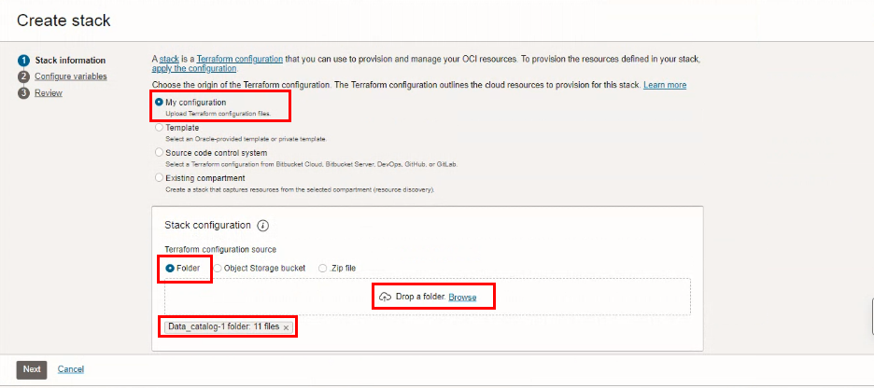

Select the parameters as per the below screen,
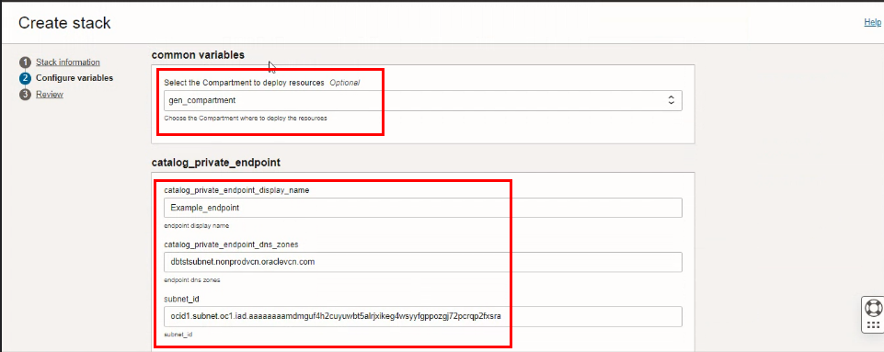

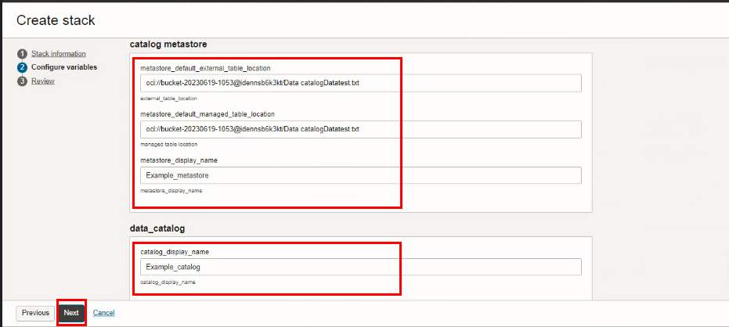
Click “NEXT”
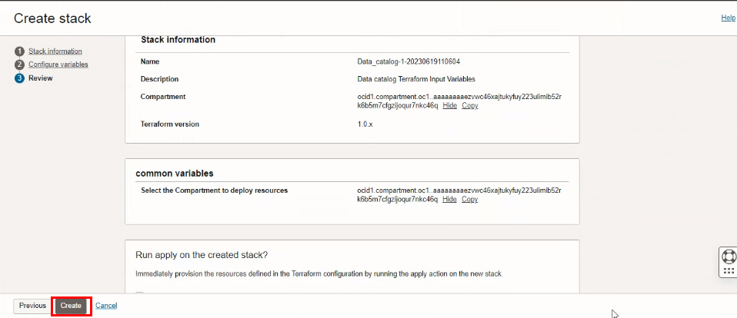
Click “CREATE”

Plan the Job

Click the “Plan”
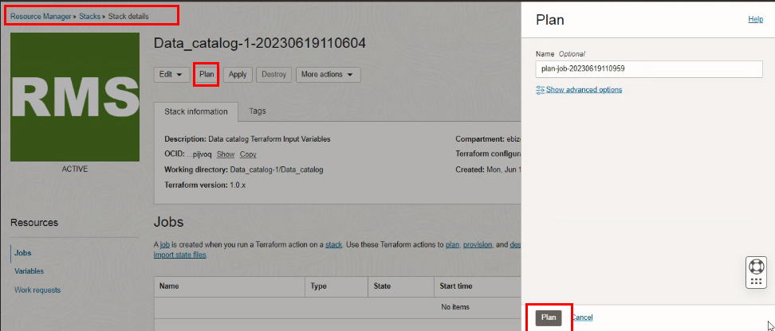

Verify the Plan is successful.
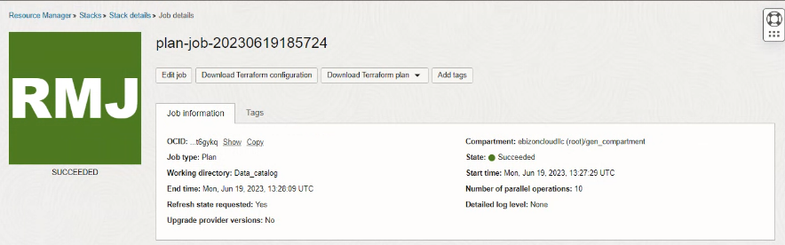
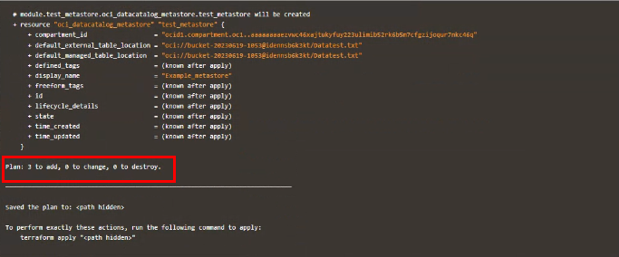

Apply the Job

Once the “plan” is success, now click “Apply”
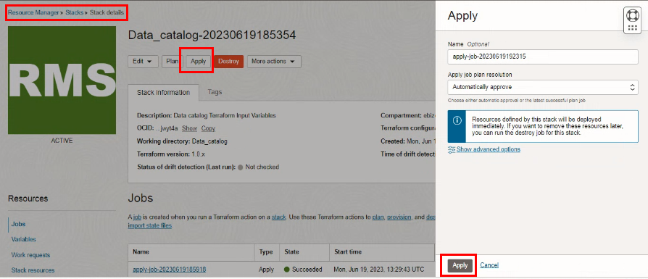

Verify the Apply is successful.
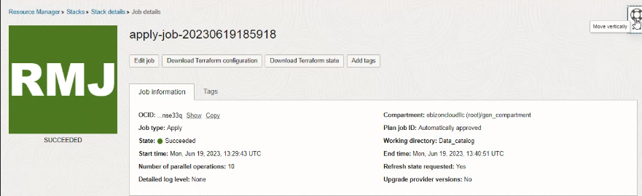
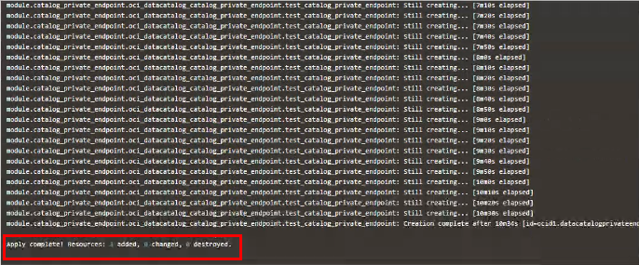

Verify in the Console

Go to OCI Console Analytics & AI Data LakeData Catalog

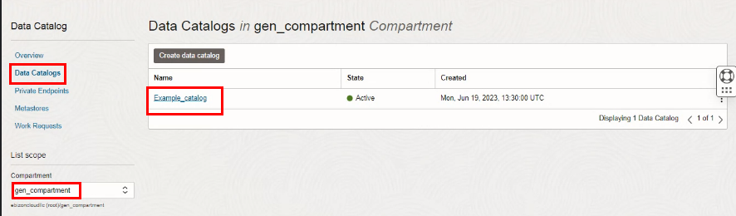

Go to OCI Console Analytics & AI Data Lake Data CatalogPrivate Endpoint 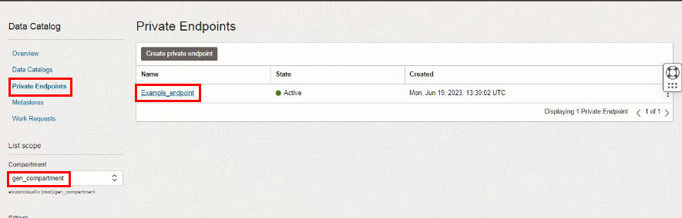

Data CatalogPrivate Endpoint Example endpoint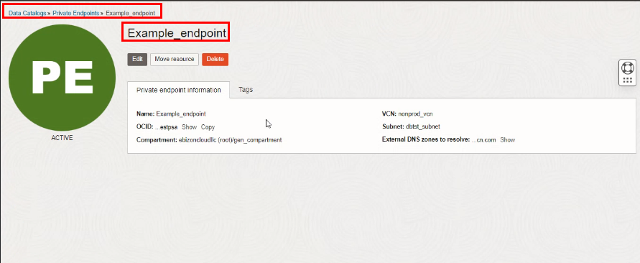

Go to OCI Console Analytics & AI Data Lake Data Catalog Metastores 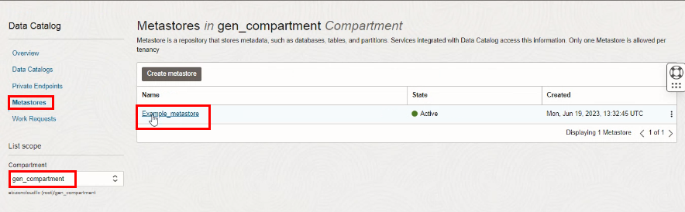

Data LakeMetastoresExample_metastore

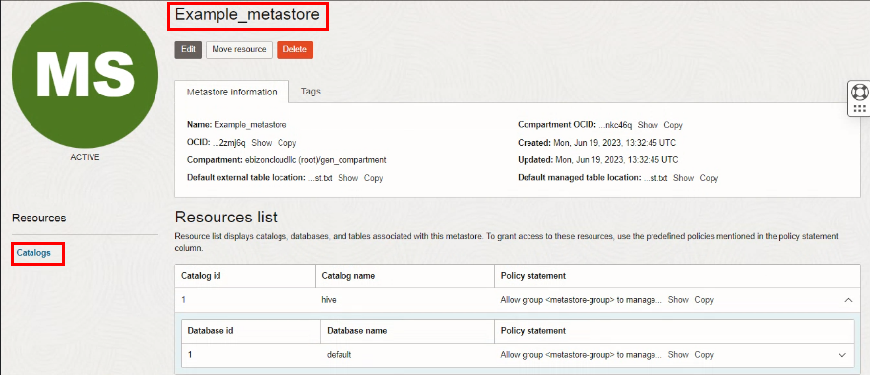

Destroy the stack

Create a destroy job in Resource Manager to release resources associated with a stack and clean up the tenancy. Once destroyed data cannot be recovered from resources.

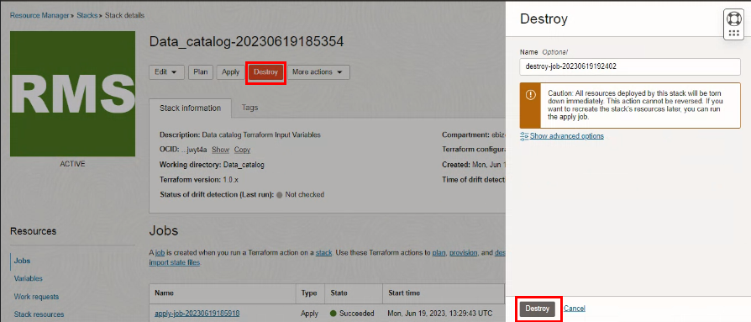

#END#

